1. First Module - Time Clock, User Story: Employee

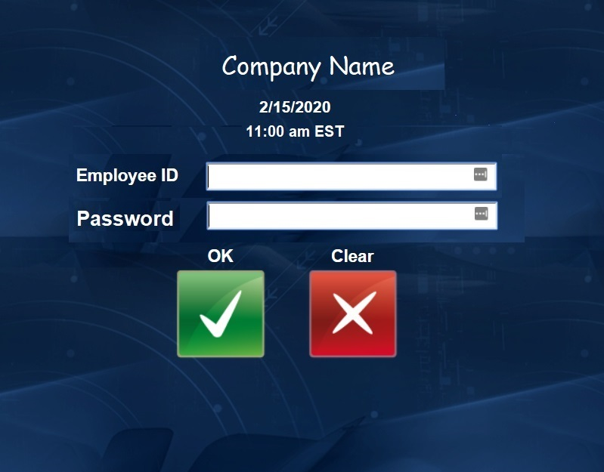

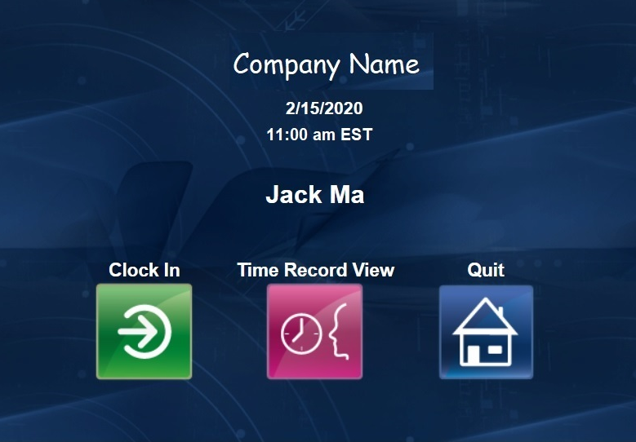

All user interface graphics are for demonstration purposes only. The Final product could look significantly different. This user story is only intended to show functionality of the program.

1. When employees or managers visit the HR system website, they will see something similar to the picture left. Stating the company name, the date, the time and two fields asking for their employee ID and password.
2. The company name of course can be changed to any company name who utilize our product, for our project, it should say Team Grammers LLC.
3. The date and time should be displaying real time for the employee, including the correct time zone. As I am in Toronto, it should say EST, if someone who resides in Chicago or Springfield use this program, it should say CST.
4. There are two buttons, one to confirm the log in, the other to clear everything to blank, allowing the user to re-enter information.
5. After the employee logs in, the program should determine if the employee has clocked in today. If not, the employee should have the option to clock in or to view their time record for another day.
6. The employee should have the option to quit and log out of the program at any time. The program should be making sure the employee is actively using the program and logs out the employee after 30 seconds of inactivity for security purposes.

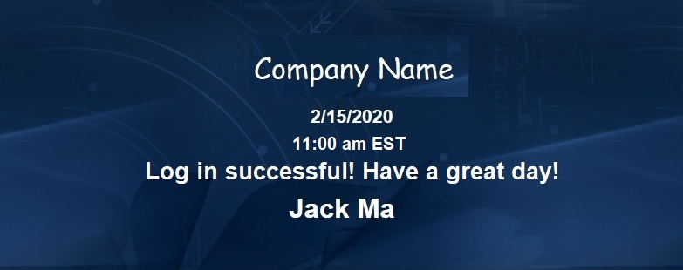

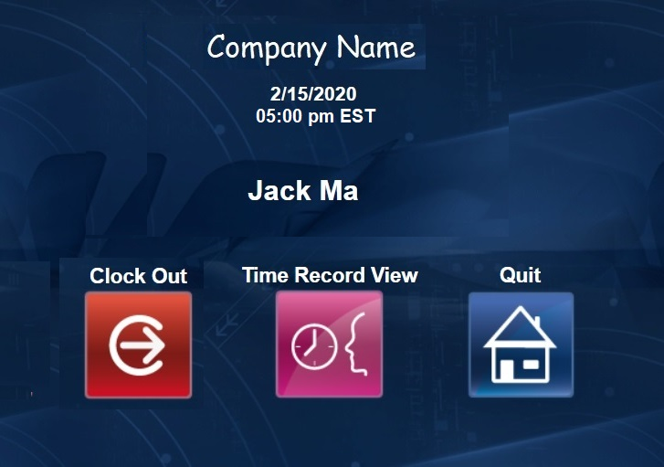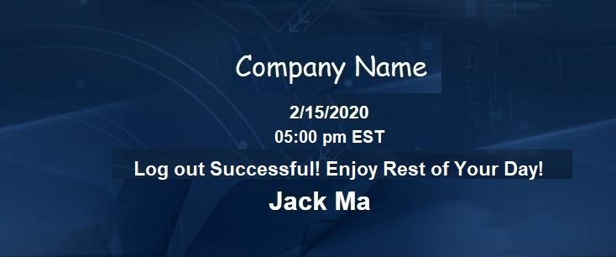

1. After the employee clicks on the “Clock In” icon, the system should confirm the employee’s action with a brief message saying “Log in scucessful! Have a great day!” This message should be displayed for 5 seconds.
2. After the successful clock in message or if the employee clicked on the “Quit” icon, the program should simply redirect the employee to the log in page again, as displayed on the first image.
3. If the employee logs in after they have already clock in that day, then the system should replace the “Clock In” icon with the appropriate “Clock Out” icon.
4. The “Time Record” icon should not change, so the employee has the ability to see their time record at any time.
5. Once the employee hit the “Clock Out” icon, the system should register the clock out, and display the message “ Log out successful! Enojoy the rest of your day!” to the employee.
6. Again this message should stay on screen for 5 seconds, after that, the user should be redirected to the main screen as shown on the first image the story.

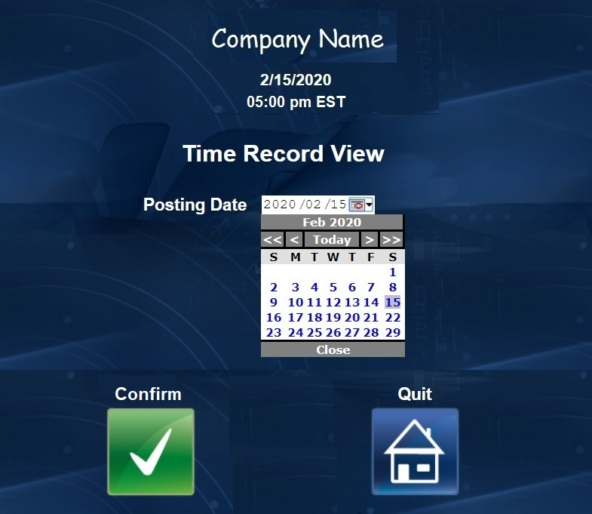

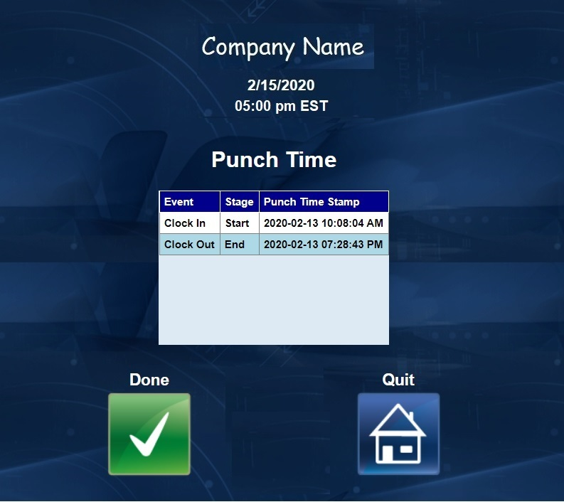

1. If the employee selects the “Time Record” icon, then the program should take the user to a screen where the user can select a date from a drop down calendar.
2. Once the user has selected the date, then the user can hit the “Confirm” icon.
3. After the user hit confirm, the program should display all the time clock activity on that day. Including clock in and clock out time. In future releases we can add in lunch out and lunch in for California users, as California requires employers to track employee lunch.
4. If the user hit “Done” icon, the system should take to screen shown on image 2 or 4 as appropriate, based on if the user has clocked in today.
5. In actual implementation, we should have another column to indicated if the time have been approved or rejected.
6. First Module - Time Clock, User Story: Manager

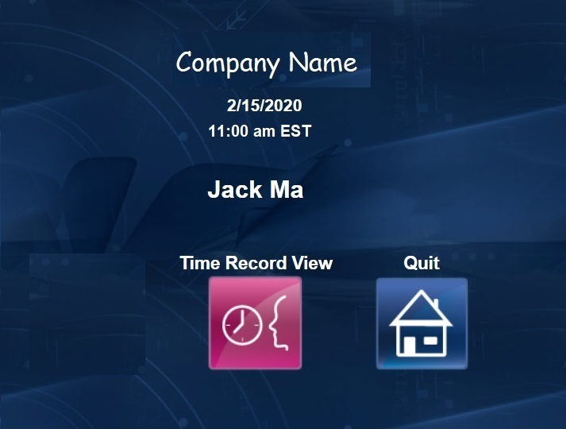

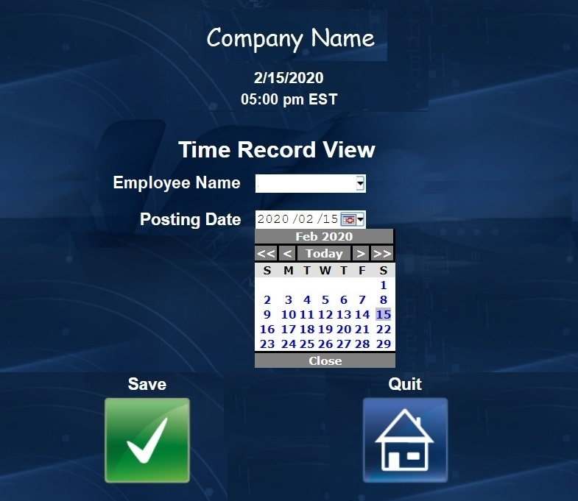

1. Managers and employee should see the same default log in screen as shown in picture 1 of the story. However manager should not be able to see the “Clock In” or “Clock Out” icons at all.
2. Instead, the manager should only be able to see two icons, “Time Record” and “Quit”, both available to regular employees.
3. The Time Record View module is different for a manager, as they have the ability to see the time events of all employees. As such, a drop down box is available to a manager with all the names of employees under this manager.
4. Again, the manager must select a date to display all the time clock events for an employee on that particular day.
5. In future developments we will explore the possibility to have the manager leave the employee name box and view all employee time clock events at the same time. Or allow the manager to select a time ranger to view the time clock events of an employee or a group of employees over a week or longer.

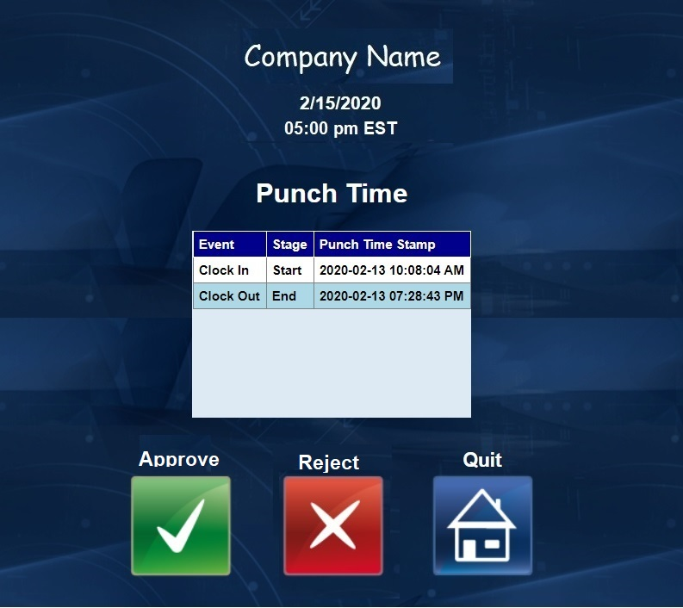

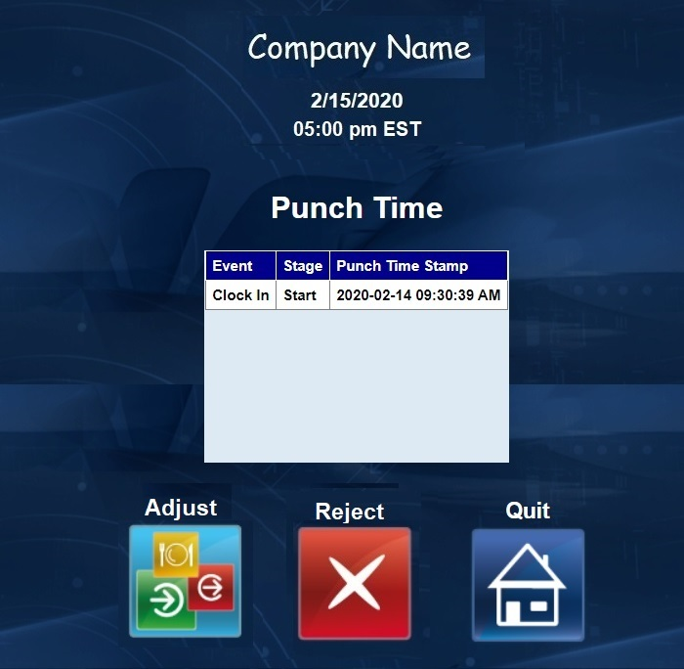

1. Once the manger has selected the employee and the date, the manager should see the information that is also available to the employee.
2. The mananger has the ability to approve or reject the time clock events. The manager does not have the ability to partially approve or reject the time clock events in a day, only approve or reject all time events at the same time.
3. If the time clock events are deemed to be erroneous, the the system would give the manager the ability to make adjustments or to reject the time clock events.

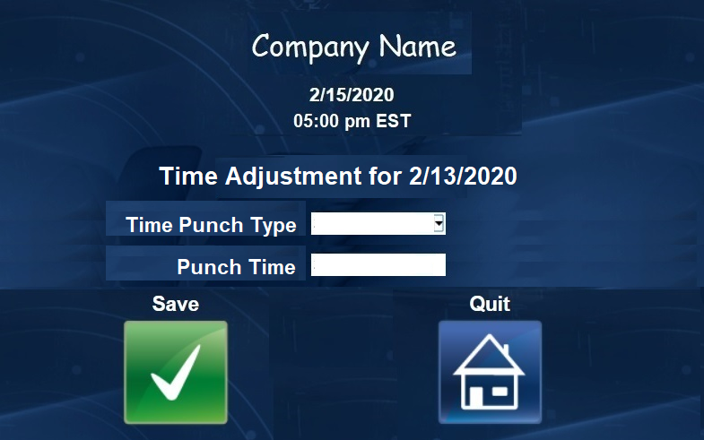

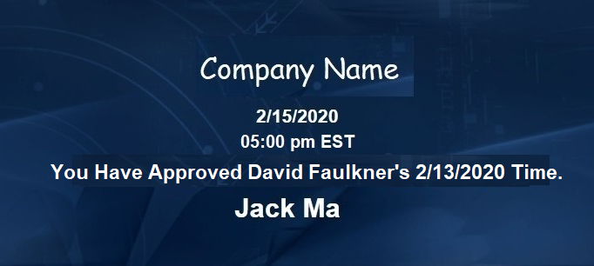

1. If the manager chooses to make an adjustment for that day, then the program will bring the manager to the screen on the left. The manager can pick the type of time clock event, the options for now should be clock in or clock out. Also, the manager must enter a time.
2. If the type of clock event already exists in the log, then the system should return an error message when the manager clicks save. If the time entered conflicts with existing time clock event such as the clock in time is after the clock out time, then the system should also return an error message.
3. If the manager enters a valid time clock event with a valid time, then the program should transfer the user back to time display page as shown in the previous picture.
4. Once the manager is satisfied with the time clock events and the manager hits the “Approve” or the “Reject” icon, the program should return a confirmation message indicating the name of the employees and the date of the time clock events.
5. The message should be displayed for 5 seconds until the user is returned to the first page of the manager story. The user should be not be returned to the log in page, but instead be allowed to perform more actions.
6. Second Module - Time Off Request, User Story: Employee

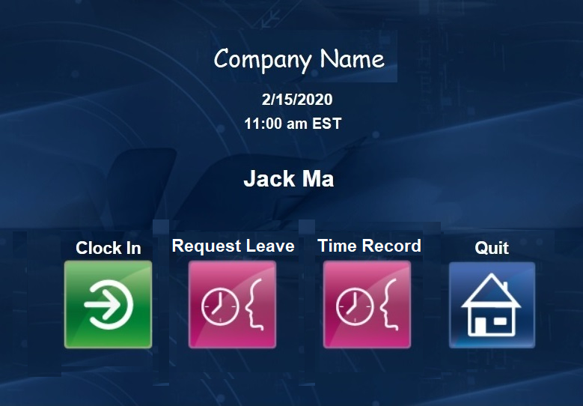

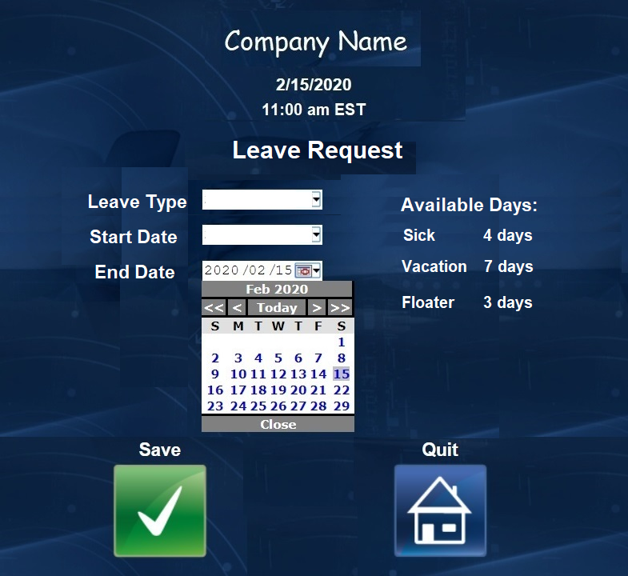

Note: the icons used in the second module do not reflect what they will look like in the final product. I do not have other icons available, so I reused them. In the final product, we will have different icons for each function.

1. After the second module is implemented. There will be four icons available to each employee user, “Clock In” or “Clock Out”, “Request Leave”, “Time Record”, and “Quit”.
2. When an employee clicks on the “Request Leave” icon, the employee will be brought to a page like the left image. Where the employee can see the available leave time they have, including sick days, vacation days, and floater days. In the future we might add bereavement days, short term disability, and maternity leave.
3. There should be three drop down boxes on the left of the page. One for the type of leave, and two more calendar drop downs. The employee could select any day to start a leave and any day to end a leave.
4. After all three drop down boxes are filled, the employee can select “Save” icon to initiate the request. If the date range is not valid, such as the end date is before the start date or the date range contains days already in another leave request, then the employee will see an error message.

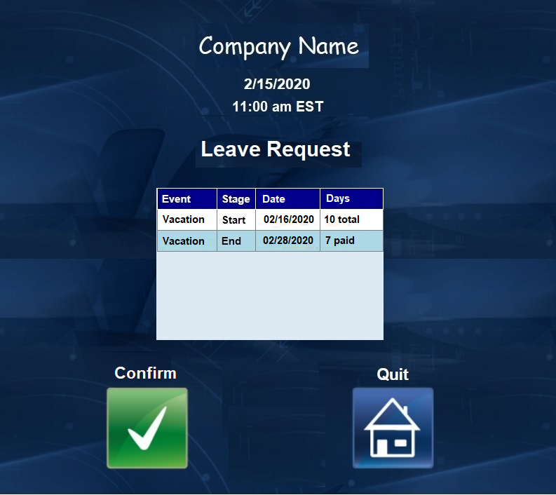

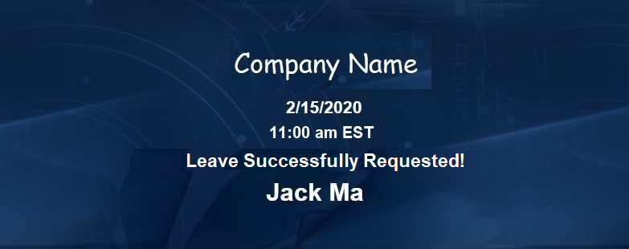

1. The system will calculate how many days the leave is in total, and how many paid days can be deducted. The system will remove all weekend days from the selected date range, and only allow the employee to take as many paid leave as available to the employee.
2. Once the employee confirms the information is correct, then the employee can submit the leave request by hitting the “Confirm” icon.

1. After a valid submission, the system will display a confirmation message to the employee for 5 seconds. Afterwards, the employee is logged out of the system and returned to the page on image 1.
2. Second Module - Time Off Request, User Story: Manager

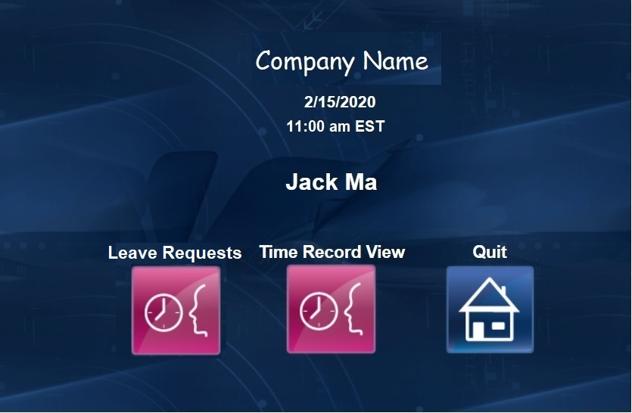

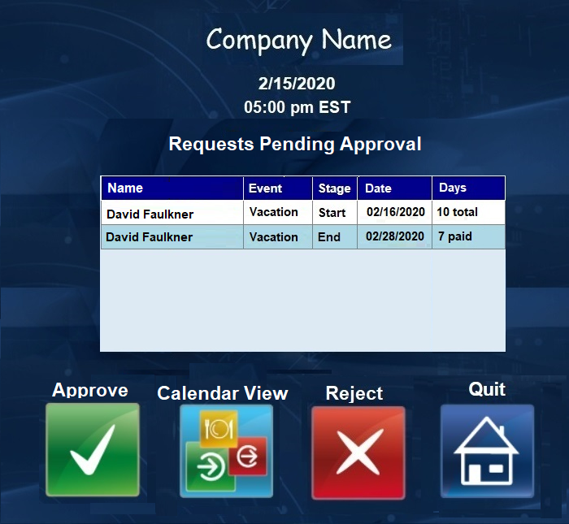

1. The manager also has an additional icon after logging into the system. Now the manager can check all leave requests by hitting the “Leave Requests” icon.
2. The manager will be directed to a pending approval page, where all pending leaves awaiting approval are displayed in a list, showing the oldest request at the top.
3. The manager can approve each request by click and highlighting a particular request, and then click on the “Approve” icon, or reject it by clicking on the “Reject” icon.
4. If the manager is concerned with conflicts or want to view already approved leave requests. Then the manager can hit the “Calendar View” icon.

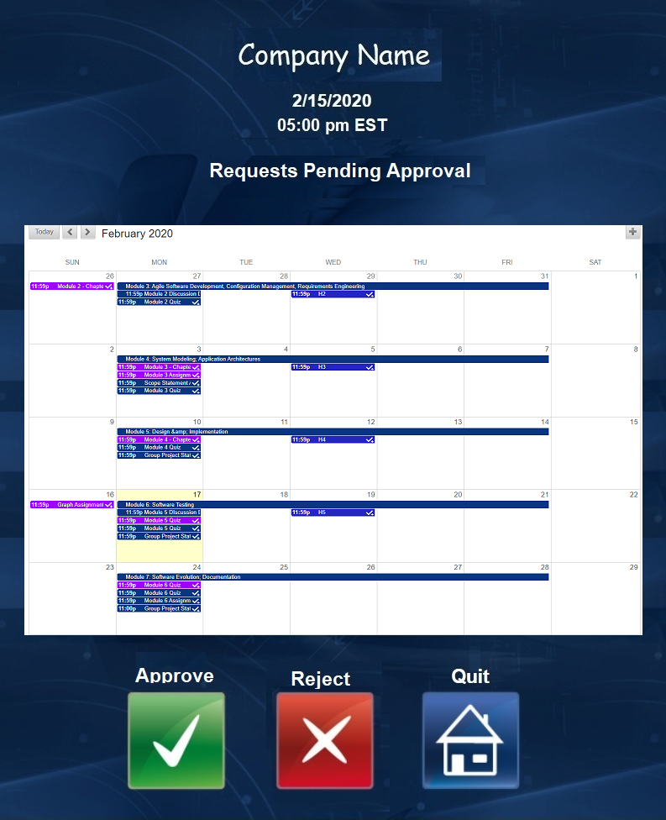

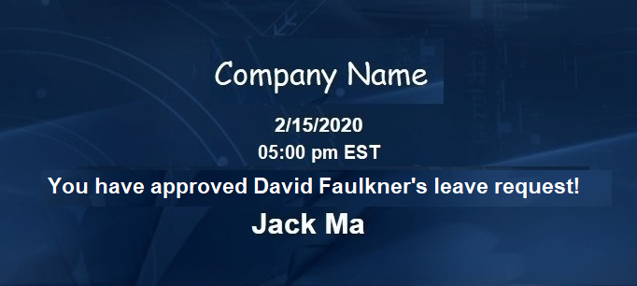

Note: I do not have a good calendar graphic so I just used the BlackBoard calendar, we will implement a similar system but instead of my tasks, our calendar will display all the leave requests with employee names.

1. The manager can see all pending leaves and all approved leaves. This way the manager can avoid any scheduling conflict. All approved requests will be highlighted green, all pending requests will be highlighted yellow, and the part of the pending request that will be unpaid will be highlighted orange.
2. The manager can click on any pending leave request and hit the “Approve” icon to approved the request, or the “Reject” icon to reject the request.
3. After the manager approves or rejects a request. The system will display a confirmation message for 5 seconds, before returning the user back to the pending approval list page.

Third Module - Adding and Removing Users, user story: HR Administrator

Note: I ran out of graphics, so this part of the user story needs further work.

1. We will add a third level of user access, the HR administrator, to allow addition and removal from our database without accessing the database directly.
2. Most importantly, the HR Administrator will be able to add and remove users, even managers and change a regular employee to a manager or vice versa.
3. The HR Admin can modify all time clock events on any day for anyone. Even approved time clock events. Also modify all leave requests for anyone regardless of approval status.
4. The HR admin cannot approve any time clock events or leave requests.
5. The HR admin can add or subtract any leave day available to any employee. There is a default amount of leave days per year and will be reset on January 1st of each year.